**Course Creation Module Documentation**

**Purpose**

Allows educators to design, customize, manage, and test their courses. It provides the flexibility to add or remove various elements, assign roles and even view the course from a student's perspective.

**Usage**

**How to create a course**

There are several ways you as admin can create a course. The two most common are:

* Create a new, empty course.
* Upload an existing course from a different Moodle site.

**Create a new empty course**

1. Log in with your administrator account.
2. Click **Site administration**.
3. Click the **Courses** tab.
4. Click **Add a new course**.
5. Add your course details, using the icon for extra help.
6. Click **Save and display**.
7. Click **Proceed to course content** to add your teaching materials.

**Upload an existing course**

1. Make sure the course you want to upload (known as a “course backup”) has the file ending **.mbz**
2. Log in with your administrator account.
3. Click **Site administration**.
4. Click the **Course** tab.
5. Click **Restore course**.
6. Drag in or upload your .mbz file into the space **Import a backup file**. 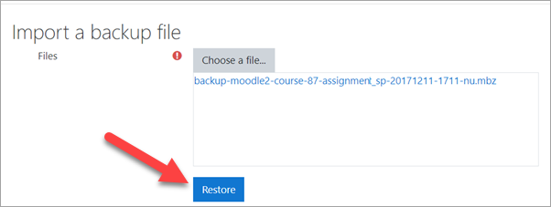
7. Click **Restore course**.
8. In the “Restore as a new course” section, click the button next to “Miscellaneous” OR click the button of the category where you want to upload your course and then press **Continue**.

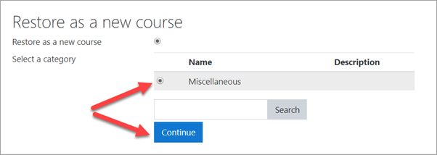

1. Click the **Next** button at the bottom of the next two pages.
2. Click **Restore** on the final page. Your course will then be displayed.